KNOWLEDGE AND LEARNING WEEK

Women in Arabia and Islam: Women pioneers in culture and education from the Arab and Muslim world

Women’s Pavilion Programming
in co-curation with Louvre Abu Dhabi

Concept Note
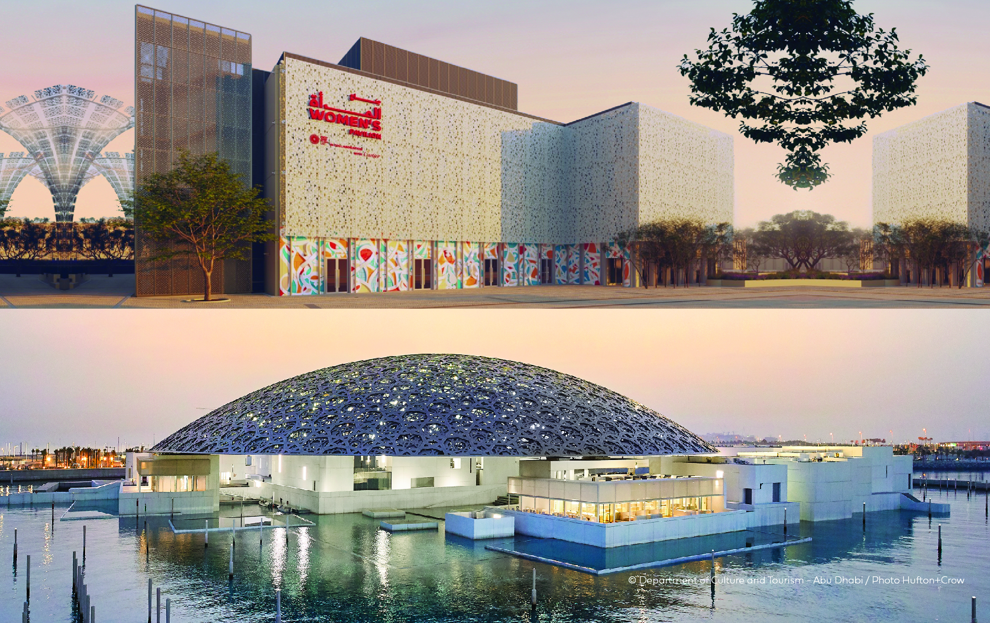

Date | Thursday 16th December, 2021
Time | Event time: 16:00-18:00 Dubai Time  Arrival time: 15:30 at the Women’s Pavilion
Venue | Women’s Pavilion Majlis
Overview | Women from the Arab and Muslim world have always pioneered in the field of education, from Fatima Al-Fihri, who established the world’s first university in Morocco the 9th century; to Sitt Al Sham, who sponsored the advancement of sciences and arts in Syria in the 12th century; to Princess Fatima Bint Ismail, who donated land and sponsored the building of Cairo University in 1914; to Sheikha Fatima Bint Mubarak, the mother of the United Arab Emirates, who prioritized the education of women and girls with the formation of the United Arab Emirates and supported free public education for all till today. Beyond the formal pillar of education, women also contributed to shaping knowledge, instilling values, and developing fields of art, literature and poetry.  While Arabic poetry played a transformative role in history, women’s contributions were often overlooked. Throughout history, women were not only the inspirations and central figures of both oral or written literature, but also have taken major parts in the composition, narration and transmission of poetry, legends and stories. Spanning 7,000 years, from the sorrowful rithā’ (eulogies) of Khansa to the gleeful scorn of Wallada bint al-Mustakfi, from diwans (collected poems) to ghazal (love-song), Arab women boldly refused to be silenced. The vibrant words from Arab and Muslim women celebrate feminine wit and desire, pushed boundaries of social and cultural norms, and nurtured generations.  Poetry has always prevailed in the Arab world, and women has spearheaded the movement since its dawn. From pre-islamic to Andalusian periods, beautiful and powerful females in the history of poetry have not only promoted the Islamic values and Arab culture to other parts of the world, but also inspired women's suffrage movements in the Arab region.  Today, poetry is also a driver for social changes. Poetry can be part of manifestations that allow us to express ourselves via non-conventional ways. When unable to challenge ideas such as gender-based stereotypes, we use poetry to speak up, stimulate critical senses, reach a wider audience as well as leave a lasting impact. It is oberserved that there is an increasing use of poetry to promote gender equality and women’s empowerment.  As such, through this panel our goal is to recognize and celebrate Arab and Muslim women as culture carriers, nurturers and educators, who have shaped and inspired the minds of generations across history and continue to do so today in our modern world. The imprint of women of Arabia and Islam in poetry cannot be denied and will not be stopped.
Key Questions | Join us in the Women’s Pavilion to explore how better we could recognize the role of women from Arabia and Islamic region and amplify their positive contributions in through poetry and literature:  - What is the role of women from Arabia and Islamic region in advancing poetry and literature and in turn what is Arabic poetry’s role in promoting gender equality and women’s empowerment?  - How does poem and literature pass on the values of a community and nation to generations? How have poems shaped our cultural identities?  - What are some of the gender-based stereotypes and challenges we face today in the field of literature, especially in the Arab and Muslim region?

APPENDIX 1 | Introduction of the Women’s Pavilion at Expo 2020 Dubai, Louvre Abu Dhabi, Women in Arabia and Islam series
EXPO 2020 DUBAI

Since the first Great Exhibition held in London in 1851, Expos have connected people and provided special spaces to spark dialogue amongst those who are curious about the future.
Running from 1 October 2021 to 31 March 2022, Expo 2020 Dubai will bring the world together to imagine, design and build a more sustainable, dignified and prosperous world. One that is cleaner, safer and healthier. One inspired by collective action around shared challenges, and in which future generations will flourish. Under the theme of “Connecting Minds, Creating the Future” and our three sub-themes of Sustainability, Mobility and Opportunity, Expo will be a platform for positive, collaborative change.

THE WOMEN’S PAVILION AT EXPO 2020 DUBAI

Our Women’s Pavilion, under the exhibition title ‘New Perspectives’, is a critical component of this vision and will be curated by Expo 2020 Dubai in collaboration with Cartier. In highlighting the positive contributions of women, we will demonstrate that when women thrive, so too does all of humanity.

The UAE has dedicated itself to ensuring that issues related to gender equality and women’s empowerment (GEWE) are centrally addressed in everything we do at Expo 2020 Dubai. By shining a light on women past and present, known and unknown, the Women’s Pavilion challenges the misconceptions that women still frequently face, seeks out new perspectives on the impact women bring to our world, explores new approaches to creating a more equal world, and identifies ways in which we, together, can create new perspectives, change deep-rooted perceptions, and adjust mindsets.

Through different modes of convening, our goal is to highlight that the only way to peace, prosperity, and sustainability is through the full and equal participation of women.

LOUVRE ABU DHABI

Created by an exceptional agreement between the governments of Abu Dhabi and France, Louvre Abu Dhabi was designed by Jean Nouvel and opened on Saadiyat Island in November 2017. The museum is inspired by traditional Islamic architecture and its monumental dome creates a rain of light effect and a unique social space that brings people together.

Louvre Abu Dhabi celebrates the universal creativity of mankind and invites audiences to see humanity in a new light. Through its innovative curatorial approach, the museum focuses on building understanding across cultures: through stories of human creativity that transcend civilisations, geographies and times.

The museum’s growing collection is unparalleled in the region and spans thousands of years of human history, including prehistoric tools, artefacts, religious texts, iconic paintings and contemporary artworks. The permanent collection is supplemented by rotating loans from 13 French partner institutions, regional and international museums.

Louvre Abu Dhabi is a testing ground for new ideas in a globalised world and champions new generations of cultural leaders. Its international exhibitions, programming and Children’s Museum are inclusive platforms that connect communities and offer enjoyment for all.

WOMEN IN ARABIA AND ISLAM

Women in Arabia and Islam is a series of ten cultural talks held in partnership with the Louvre Abu Dhabi research programme inspired by the artworks of the Louvre Abu Dhabi museum and celebrating the rich Muslim heritage. Taking a historical and cultural perspective, the events focus on sharing and recognizing the positive role women from Arab and Islamic backgrounds have played in the course of history until today.

APPENDIX 2 | Relevant facts and figures to prepare for the session

