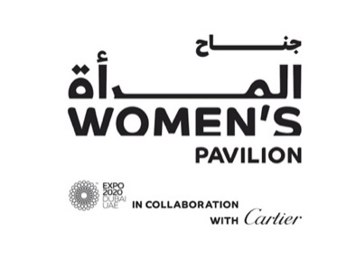

presents in collaboration with

KNOWLEDGE AND LEARNING WEEK

132 million girls: Tackling gender disparities in access to education

Women’s Pavilion Programming, in partnership with World Majlis

Participant Briefing

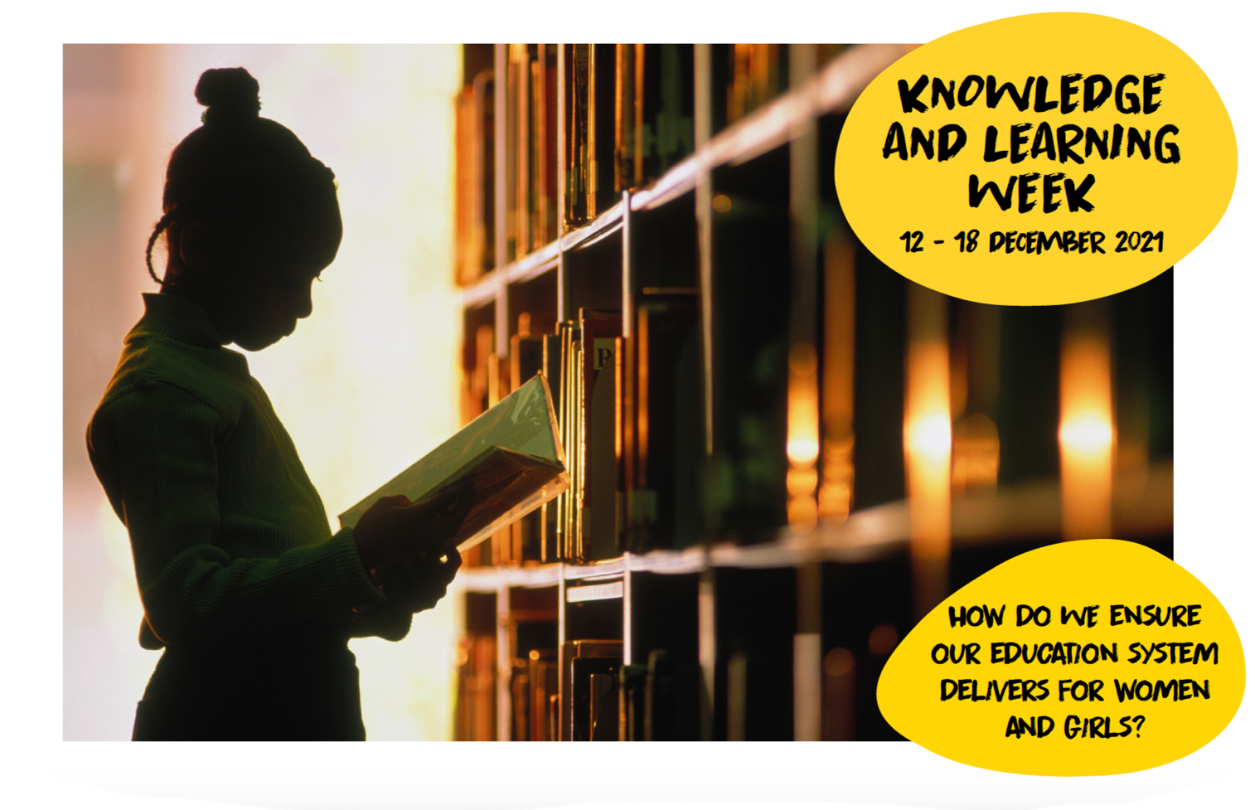
Co-curation | Dubai Cares,  Kingdom of Saudi Arabia Pavilion,  and United States of America Pavilion,
Date | Monday December 13th, 2021
Time | - Meet at 10:30 AM at the Women’s Pavilion Majlis  - Discussion on stage 11:00-12:30 PM Dubai Time  - Women’s Pavilion tour 12:45 PM – 13 :15 PM Dubai Time
Venue | Women’s Pavilion Majlis
Overview and  Key Questions | If you educate a woman, you educate a family, if you educate a girl, you educate the future. Sadly, we still have 132 million girls out of school today.  Twice as many girls as boys will never start school, according to UNESCO. Today only 49 per cent of countries have achieved gender parity in primary education. Threats to girls’ education range from poverty, child marriage, gender biases, poor infrastructure, and conflict, to a lack of gender-responsive pedagogies, policies, data, budgets and more.  The COVID-19 pandemic has disrupted the entire education sector. The increased drop-out rates disproportionately affect girls, which further entrench gender gaps in education and lead to increased risk of sexual exploitation, forced marriage, early pregnancy. The world also faces challenges in updating our educational system and infrastructure to provide e-learning for tomorrow.  Investing in girls’ education is investing in economic growth, a healthy workforce, lasting peace and a sustainable future for our planet. One additional year of schooling increases a woman’s return from education by 12 percent compared with 10 percent for men. Gender-equitable education could add up to $12 trillion USD to global growth. It can also cut the risk of violent extremism in half. To have a healthy, prosperous and sustainable society, we must guarantee girls’ education.  - How do we guarantee every girl goes to school?  - What are the best practices for promoting gender-inclusive classrooms and learning?  - What is the future of education? How do we ensure that e-learning is gender-responsive?  Please join us in this Women’s World Majlis to share your insights and collectively contribute to building a more gender-equitable future.
Audience & Media | The event will be live-streamed via the Virtual Expo platform. More details, such as the session link, will be shared closer to the event.  Your short biography will be shared digitally as part of the event.  Media opportunities: Please let us know if you request for media interviews.

Opening message – video input (10 min)
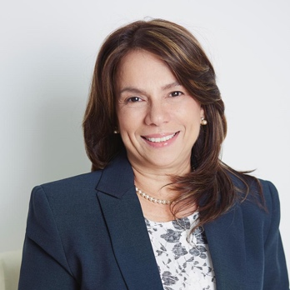 | HE Maruja Gorday de Villalobos  Minister of Education, Panama  Gorday graduated as a comprehensive teacher of Special Education with specialisation in Early Stimulation, Vision, Hearing and Language from the Higher Institute of Specialisation. She was representative of the Ministry of Education (MEDUCA) in the Permanent Multisectoral Council for the Implementation of the Dialogue for Education (COPEME), representative of MEDUCA in the Table of the Dialogue Commitment to Education, candidate to the United Nations Committee of Experts on the Rights of Persons with Disabilities.  She has participated in various conferences, training and professional development courses such as the workshop on exchanges of experiences in the implementation of learning assessment systems (MEDUCA), conference on educational policies to promote quality and the culture of Educational Assessment and the Franklin Covey's Strategic Planning course.  Gorday participated in the preparation of the document ‘A Call to Action: National Commitment to Education: Let's Take the Next Step’ and was part of the team of collaborators of the first statistical model to establish educational indicators.
Panel discussion (60 min)
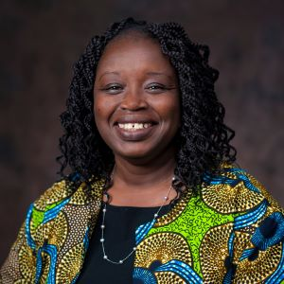 | Dr. Fanta Aw – Moderator  Vice President of Campus Life, American University (Washington D.C.), USA  Dr. Fanta Aw is Vice President of Campus Life at American University in Washington D.C. She has spent 28 years in higher education administration, most recently as Assistant Vice President of Campus Life. She advises American University leadership on matters related to campus internationalization, issues of inclusion, diversity and equity, and student engagement.  Dr. Aw is also the School of International Service’s Hurst Senior Professorial Lecturer; she teaches graduate courses related to immigration, internationalization of higher education, and international higher education policy.  She is the 2013 recipient of the University Award for Outstanding Teaching in an Adjunct Position.
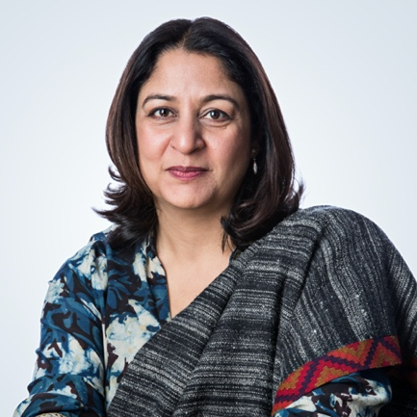 | Safeena Husain – Panelist  Founder and Executive Director of Educate Girls (EG), India  Safeena is the Founder and Executive Director of Educate Girls (EG), an Indian non-profit that mobilises communities toward girls’ education in some of the hardest-to-reach villages. Under her leadership, EG has enrolled 950,000+ girls in schools till date, impacted over 11.5 million+ beneficiaries, expanded operations to 20,000 villages through a 15,000+ strong team of community volunteers.  An LSE graduate, Safeena has worked extensively with underserved communities in South America, Africa and Asia. She is known for her efforts to bridge the gender and literacy gaps through tech-driven interventions, pioneering the world’s first Development Impact Bond in education and EG becoming the first Audacious project in Asia, that aims to bring 40% of India’s out of school girls back to education.
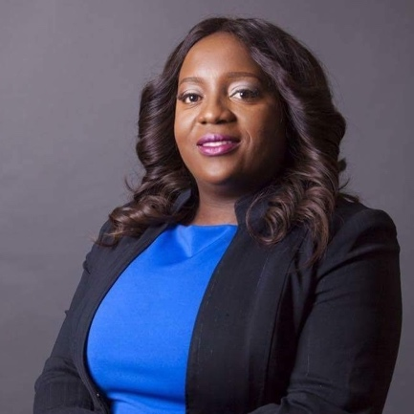 | Vongai Nyahunzvi – Panelist  Chief Network Officer, Teach for All, UK  Vongai Nyahunzvi is Chief Network Officer at Teach For All, a global network of independent organizations working to develop collective leadership to ensure all children can fulfill their potential. Vongai has held senior leadership positions across the corporate, government, and not-for-profit sectors for more than 20 years. She is known for her entrepreneurial approach and her passion for helping senior leaders think clearly, strategically, and practically.  Vongai has an extensive track record of building strong relationships, trust, and engagement at all levels. Prior to her current role, she was the Head of the Africa Region at Teach For All, where she oversaw the support and engagement with network partners in the region as well as the launch of new organizations in Africa. For eight years, Vongai ran her own leadership and organizational development practice, supporting senior leaders in organizations, including chief executives, heads of UN agencies, and managing directors, across four continents and multiple sectors. She has also held senior director-level positions in organizations including BT Global and Royal Holloway University in the UK.  Vongai is recognized as a thought leader on leadership development and has authored two books on the topic, Leading From Within — Shifting Perspectives on Leadership (2015) and Leadership Syndromes — Identifying the Self-sabotaging Behaviour Patterns that Can Derail Your Effectiveness as a Leader (2016). In 2016, she launched a monthly roundtable for CEOs across sectors to discuss leadership challenges at the C-suite level. She also founded the UK-based Europe Leadership Awards, which brought together senior leaders from around the world.  In addition to her role at Teach For All, Vongai sits on a number of Boards where she provides strategic input. Born and raised in a patriarchal society, she is passionate about ensuring that girls around the world can thrive. She is a proud mother of three boys and lives in Corby, United Kingdom.
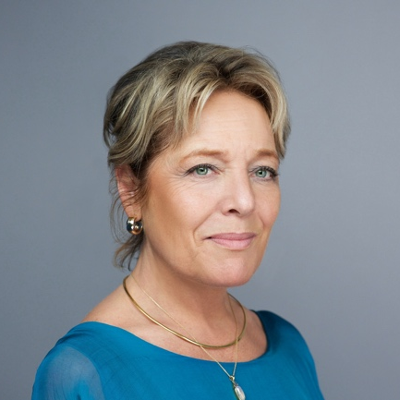 | Yasmine Sherif – Panelist  Director, Education Cannot Wait (ECW) United Nations  Yasmine Sherif is the Director of Education Cannot Wait (ECW), a global fund for education in emergencies and protracted crisis, established at the World Humanitarian Summit and hosted by UNICEF.  A human rights lawyer with 30 years of experience in international affairs, including 20 years in management & leadership, she graduated with an LLM from Stockholm University in 1987 and joined the United Nations in 1988.  She has served in New York, Geneva and in crisis-affected countries in Africa, Asia, Balkans and the Middle East. She has in-depth knowledge and first-hand experience of the UN humanitarian, development and political system, crisis/post-crisis and the humanitarian-development nexus. She has also served with NGOs and as Adjunct Professor at Long Island University.
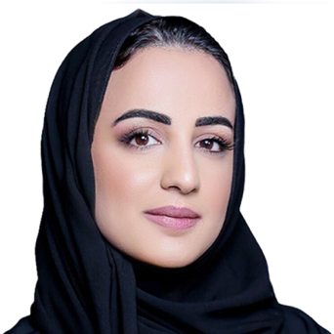 | Dr Mounira Jamjoom – Panelist  CEO & Saudi Entrepreneur, Aanaab Holding, Saudi Arabia  Dr. Mounira Jamjoom is a Saudi entrepreneur, education expert and author who specializes in building and improving teacher capacity.  Jamjoom is the co-founder and CEO of Emkan Education, a consultancy and education development company which provides services to public and private institutions, including school operators, educators and investors.  She also founded Aanaab.com, a digital platform with resources and training courses for teachers and educators in the Arab world.  Jamjoom has a wealth of experience in education in Saudi Arabia and has written extensively on the subject, including two books.  She is a member of the sixth class of Middle East Leadership Initiative Fellows and the Aspen Global Leadership Network. She previously served as assistant governor in the Kingdom for the Evaluation, Training and Education Commission.
Q&A Session (20 min)

Appendix
- Relevant facts and figures to prepare for Majis session
Primary and secondary education shortfall for girls
- According to UNICEF, the 132 million girls around the world who are not in school include 34.3 million girls of primary age, 30 million of lower secondary school age, and 67.4 million of upper secondary school age.
- Only 66 percent of the world’s 195 countries have achieved gender parity in primary education. That drops to just 25 percent of countries with equality in upper secondary education.
https://www.unicef.org/education/girls-education
- The toughest place in the world for a girl to receive an education is the world’s newest country – South Sudan – where almost three quarters of girls do not even make it to primary school. Afghanistan is ranked fourth due to its wide gender gap, and the remainder of the list are countries in Sub-Saharan Africa including Burkina Faso, Central African Republic, Chad, Ethiopia, Guinea, Liberia, and Mali.
https://www.bbc.co.uk/news/business-41558486
- Following lengthy school closures in the wake of the Covid-19 pandemic, the World Bank predicts that large numbers of girls will simply not return to the classroom.
“Many girls’ responsibilities in terms of household work and caregiving are likely to have increased during the school closures – reducing the time available for studying. Indeed, research shows that when primary caregivers are missing from the household (which may often be the case during the pandemic/as a result of COVID-19), girls are often given additional responsibilities in terms of caregiving and household tasks – further reducing the time available for studying and reducing their overall engagement in schooling.”
https://www.worldbank.org/en/topic/girlseducation
https://www.ncbi.nlm.nih.gov/pmc/articles/PMC7292576/
- Since its foundation in 2016, the Education Cannot Wait (ECW) global emergency fund has mobilised $650 million in donations. By 2021 its investments will reach 8.9 million children and young people annually. 60 percent of their total spending is on quality, affordable education for girls.
https://www.educationcannotwait.org
https://www.educationcannotwait.org/international-womens-day-2021-every-girl-has-a-right-to-an-education/
- Sustainable Development Goal 4 is to “ensure inclusive and equitable quality education and promote lifelong learning opportunities for all” by 2030.
https://sdgs.un.org/goals/goal4
- In 2016, UNESCO warned that an additional 68.8 million teachers needed to be recruited in just 14 years to meet that goal.
https://sdg.uis.unesco.org/2016/10/05/closing-the-teacher-gap-almost-69-million-new-teachers-needed/
- The Malala Fund estimates that under current rates of progress we are still 100 years away from achieving education for all girls.
https://malala.org/our-work

Gender equality in education as a force for social change
- UN Special Envoy for Global Education, and former UK Prime Minister, Gordon Brown has called the fight for universal girls’ education “the civil rights struggle of our time.”
https://www.theguardian.com/commentisfree/2015/jul/06/education-girls-world-civil-rights-malala
- UNICEF underlines that gender-equitable education benefits both girls and boys, teaching valuable life skills such as communication and negotiation, reducing harmful gender-based beliefs, acts, and practices, and builds nationwide prosperity:
“An education free of negative gender norms has direct benefits for boys, too. In many countries, norms around masculinity can fuel disengagement from school, child labour, gang violence and recruitment into armed groups. The need or desire to earn an income also causes boys to drop out of secondary school, as many of them believe the curriculum is not relevant to work opportunities.”
https://www.unicef.org/education/girls-education
- According to World Bank findings, more than 41,000 girls under the age of 18 marry every day.
- Girls with no education are six times more likely to be married as children than a girl with secondary education.
- A woman with some, or completed, secondary schooling is 11 percent, or 36 percent, respectively, less at risk of violence than women with none.
https://documents.worldbank.org/en/publication/documents-reports/documentdetail/530891498511398503/economic-impacts-of-child-marriage-global-synthesis-report
- Educating girls begins a positive cycle of reinforcement. According to UNICEF, an educated mother is more than twice as likely to send her own children to school.
- A child whose mother can read is 50 percent more likely to survive past their fifth birthday.
- A girl with a single extra year of education will result in 25 percent more income in her adulthood. This in turn affects outcomes for her entire family – better nutrition, better healthcare, less poverty and vulnerability.
https://www.unicef.org/education/girls-education

Best practices for gender equal classrooms and learning
- UK-based educational NGO, The Varkey Foundation, believes that “Every child, everywhere, deserves a good teacher.” Their research has found that a 10 percent increase in teacher’s pay results in an increase of between five and ten percent in pupil performance.
- The Foundation is trialling an interactive distance learning programme in Ghana to train 5,000 teachers on a wider scale than would be possible in person.
- The Foundation administers the annual Global Teacher’s Prize and the Global Student Prize, and works to build quality education for every child by investing in, and supporting, excellent teachers through training and publishing resources such as their handbook on ‘Gender Responsive Pedagogy”.
https://www.varkeyfoundation.org/what-we-do/research/alliances/girls-education/
- The Global Teacher prize is worth $1 million every year, and is given to an outstanding individual who has made a real difference to her/his classroom and profession.
- The Varkey Foundation has now launched its Class of Covid-19 initiative, driven by 11 Global Teacher Prize finalists around the world. This is “the first international fact-finding commission led by young people, into the impact of Covid-19 on the future of their education.” The initiative invites children from around the world to fill in an anonymous questionnaire on what they missed about school while it was closed, what they learned about themselves during lockdown, and what they would change about their school when they return to their classes. The commission will report its findings to UNESCO and the Global Education Coalition in October 2021 and will “make a series of recommendations for how governments can incorporate the voices of children into policymaking.”
https://www.varkeyfoundation.org/class-of-covid-19/
- International literacy NGO Room to Read believes “world change starts with educated children” and gives particular emphasis to girls through its Girls Education Programme (GEP) which has reached 85,313 girls across 20 countries so far, with 96 percent of them completing the programme. GEP works to keep girls in school right through secondary education, teaching them essential life skills as well as the core curriculum, and works with families, teachers, and community partners to make sure each girl can reach her full potential. It costs Room to Read $25 a month to provide a girl with everything she needs to stay in school – including books, uniform, transport, and a place in a Room to Read boarding house if she lives too far away from the classroom.
https://www.roomtoread.org/literacy-girls-education/girls-education/
https://www.roomtoread.org/impact-and-reach/

What difference would 132 million girls make?
- In countries where there is gender equitable education there is greater female participation in political life, and long-term positive impacts on economic prosperity and social norms.
- According to the World Bank a country adds on average $1 billion a year growth in GDP if it gives its girls equal access to education, and education of an equal quality, as its boys.
https://www.worldbank.org/en/topic/girlseducation
https://www.worldbank.org/en/news/press-release/2018/07/11/not-educating-girls-costs-countries-trillions-of-dollars-says-new-world-bank-report
- The Brookings Institution has called secondary schooling for girls the most cost-effective and best investment against climate change, because it empowers girls to have greater control over their reproductive health, increases their voice and their leadership abilities regarding their environment, and gives them skills to access the green jobs of the future.
https://www.brookings.edu/blog/education-plus-development/2021/02/10/why-is-girls-education-important-for-climate-action/
- The Malala Fund also highlights girls’ education as: a driver for economic growth as more women enter paid work, a route to healthier families as educated girls are less likely to marry young or be unable to care for sick infants, a way to build stable communities. Inequality leads to extremism, but when a country educates all its children equally it cuts its risk of war by half. https://malala.org/girls-education

